1.Introduction
An e-commerce website is an online platform that facilitates the buying and selling of products or services through the internet. In recent years, online shopping has become a vital part of modern business, allowing customers to browse products, compare prices, and make purchases conveniently from anywhere and at any time.
This project focuses on developing an e-commerce website using the Django web framework, which is a high-level Python framework that promotes rapid development and clean, pragmatic design. The website enables users to interact with a digital storefront where they can explore product categories, view details, and place orders securely.
The system aims to provide a user-friendly interface for customers and an efficient management panel for administrators. It ensures that users can easily log in, register, and manage their accounts while administrators can handle product uploads, inventory, and customer information through a backend dashboard.
Overall, this project demonstrates how web technologies like HTML, CSS, Python, and Django can be combined to build a fully functional and efficient online shopping platform that bridges the gap between sellers and customers in the digital marketplace. An e-commerce website is a digital platform that allows customers and businesses to buy and sell goods or services online. It eliminates geographical limitations and provides users with a convenient, fast, and secure shopping experience. Over the past decade, e-commerce has transformed the way people shop, making it possible to browse, compare, and purchase products with just a few clicks. It not only benefits consumers by offering variety and accessibility but also helps businesses reach a wider audience and operate more efficiently.
The main goal of this project is to design and develop a simple and efficient e-commerce web application using the Django framework. Django, a high-level Python web framework, simplifies web development by providing tools and libraries for building secure and scalable applications. This project demonstrates the use of Django’s Model-View-Template (MVT) architecture to create an interactive platform where users can browse products, manage their shopping cart, and place orders.
In this system, users can create accounts, log in, view product listings, and make purchases through an intuitive user interface. The website’s backend allows the administrator to manage product details, update prices, add or remove items, and view customer orders. This modular design ensures smooth communication between the frontend (user interface), backend (business logic), and database (data storage).
The project also emphasizes responsive design and data handling. The frontend is built using HTML, CSS, and JavaScript, ensuring that the site works effectively on different devices such as computers, tablets, and smartphones. Django manages server-side processing and interacts with the database to ensure that user data and product information are handled securely and efficiently.
By implementing this project, students can understand the complete workflow of an e-commerce system—from user interaction to data storage and processing. It demonstrates practical applications of web technologies, backend frameworks, and database management systems. This project also serves as a foundation for developing more advanced features like payment integration, customer feedback systems, and product recommendation engines.
In conclusion, this e-commerce website project showcases the integration of technology and commerce to create a dynamic online platform that provides convenience for users and efficiency for businesses. It reflects how programming frameworks like Django can be used to create real-world web applications that are robust, scalable, and impactful.
2. Problem Statement
In today’s digital era, online shopping has become an integral part of people’s daily lives. Customers expect quick, secure, and convenient access to products without the limitations of physical stores. However, many small and medium-sized businesses still lack a digital platform that allows them to showcase and sell their products efficiently. Developing a reliable, user-friendly, and scalable e-commerce system has therefore become a significant challenge.
Traditional shopping methods require customers to visit stores physically, which can be time-consuming and geographically restrictive. Moreover, manual inventory management and transaction handling increase the risk of human error, inefficiency, and data loss. Businesses also face difficulties in maintaining customer relationships, analyzing buying behavior, and providing personalized experiences without a digital system in place.
The primary problem addressed in this project is the need for an online system that simplifies the process of buying and selling products. The website should offer a seamless interface where customers can browse items, add them to a cart, and make secure purchases. At the same time, administrators should have complete control over managing products, monitoring orders, and updating stock information without technical complexity.
Another major concern is ensuring the security and reliability of the system. Online platforms handle sensitive data such as user credentials, personal information, and purchase details. Without proper backend management and security measures, this information is vulnerable to misuse. Hence, the system must be designed to include secure authentication, validation, and data storage mechanisms.
This project seeks to overcome these challenges by developing an e-commerce website using the Django framework. The goal is to create a robust, flexible, and interactive platform that connects buyers and sellers in a digital environment. The system aims to enhance the overall user experience, automate routine business tasks, and demonstrate how web development technologies can be applied to solve real-world commercial problems efficiently.
3. Objectives
The main objective of this project is to design and develop an efficient, user-friendly, and secure e-commerce website using the Django web framework. The website should provide a complete online shopping experience for customers while enabling administrators to manage the system with ease.
The specific objectives of the project are as follows:
- To design and implement a responsive and interactive e-commerce platform that allows users to browse, select, and purchase products online.
- To provide secure authentication features such as user registration, login, and logout functionalities to protect user data and privacy.
- To develop a dynamic product management system where administrators can add, edit, or remove product details from the database.
- To implement a shopping cart mechanism that enables users to add, view, and remove products before checkout.
- To ensure proper integration between the frontend and backend through Django’s Model-View-Template (MVT) architecture for efficient data handling.
- To design an intuitive and clean user interface using HTML, CSS, and Bootstrap for improved user experience across different devices.
- To implement backend logic for order management, allowing customers to place and track their orders effectively.
- To maintain a centralized database for managing users, products, and orders using SQLite or MySQL.
- To apply security practices such as input validation and session management to prevent unauthorized access and protect user information.
- To demonstrate the practical use of Django in building a real-world web application that connects business operations and customer needs in a digital environment.
Through these objectives, the project aims to bridge the gap between customers and sellers by creating a reliable, scalable, and modern online shopping system. The e-commerce website will not only simplify the buying and selling process but also serve as a valuable learning experience in web application development using Python and Django.

5.BLOCK DIAGRAM OF THE PROJECT
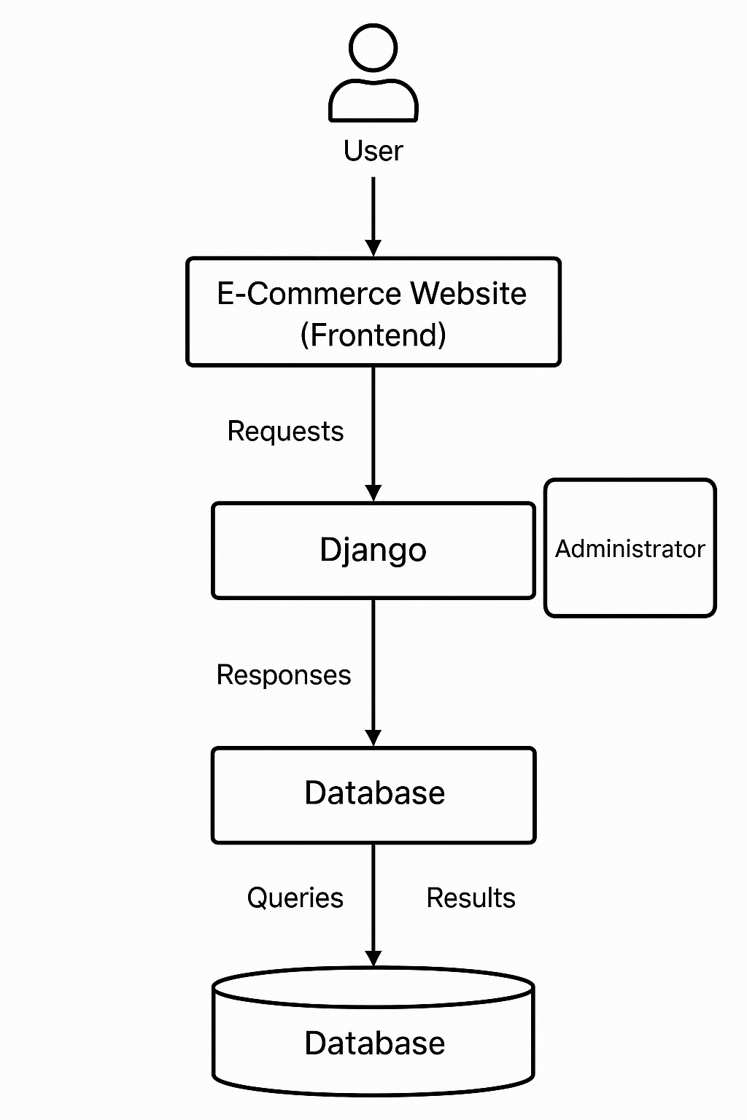

5. Modules of the Project

The e-commerce website project is divided into several interconnected modules. Each module performs a specific function that contributes to the overall working of the online shopping system. This modular structure ensures better organization, easy maintenance, and scalability of the application.
The major modules of the project are as follows:
User Authentication Module
This module handles all user-related authentication processes such as registration, login, and logout. It ensures that only authorized users can access the platform. New users can sign up by providing their details, and existing users can log in using their credentials. Django’s built-in authentication system is used to manage user sessions securely.
Product Management Module
This module is responsible for managing product details. The administrator can add, update, or delete products from the database. Each product has attributes such as name, description, price, and category. Products are displayed on the frontend for users to view. This module helps maintain an up-to-date product catalog.
Product Display Module (Frontend)
The frontend module displays all the products in a structured and attractive manner using HTML, CSS, and Bootstrap. Users can browse through product categories, search for specific items, and view detailed information about each product. It also includes navigation features for a smooth user experience.
Shopping Cart Module
The shopping cart is a key feature of any e-commerce platform. This module allows users to add products to their cart, view the total price, and remove items if needed. It dynamically updates the cart contents and stores data temporarily until the order is placed.
Order Management Module
This module handles the entire order process — from placing an order to confirmation. When a user checks out, the order details are saved in the database along with customer information. The system generates a confirmation message once the transaction is successful.
Admin Module
The admin module provides the administrator with control over the entire website. It includes a dashboard where the admin can monitor sales, manage users, and handle product inventory. Django’s admin interface makes this process efficient and user-friendly.

Database Module
This module manages data storage and retrieval. It stores user information, product details, order history, and transaction records in the database (SQLite or MySQL). Django’s ORM (Object Relational Mapper) simplifies database operations by allowing developers to interact with data using Python instead of SQL queries.
Search and Filter Module
This module allows users to search for products by name, category, or price range. It enhances usability by providing instant search results and sorting options, improving the overall shopping experience.
Payment Simulation Module (Optional)
Although the current version does not include real payment integration, this module can simulate basic checkout confirmation. It can later be extended to include secure payment gateways like PayPal or Razorpay.
Each module interacts with others through Django’s MVT (Model-View-Template) architecture, ensuring that the application runs smoothly and efficiently. Together, these modules create a complete and functional e-commerce system capable of handling real-world business operations.

6.CODE
a)STYLE.CSS
* style.css */
body {
font-family: 'Segoe UI', Tahoma, Geneva, Verdana, sans-serif;
background-color: #f6f7fb;
margin: 0;
padding: 0;
}
header.site-header {
background: linear-gradient(90deg,#4a90e2,#357ab8);
color: #fff;
padding: 18px;
text-align: center;
box-shadow: 0 2px 6px rgba(0,0,0,0.08);
}
.store-container {
max-width: 1100px;
margin: 24px auto;
display: grid;
grid-template-columns: repeat(auto-fit, minmax(240px, 1fr));
gap: 20px;
padding: 0 16px;
}
.product-card {
background: #fff;
border-radius: 10px;
box-shadow: 0 6px 12px rgba(20,20,20,0.06);
padding: 14px;
text-align: center;
transition: transform .18s ease, box-shadow .18s ease;
}
.product-card:hover {
transform: translateY(-6px);
box-shadow: 0 12px 26px rgba(20,20,20,0.12);
}
.product-card img {
max-width: 100%;
height: 160px;
object-fit: cover;
border-radius: 8px;
}
.product-card h2 { margin: 12px 0 6px; font-size: 18px; color: #222; }
.product-card p.price { color:#1b7a2f; font-weight:600; margin:6px 0; }
.btn {
display:inline-block;
margin-top:10px;
background:#4a90e2;
color:white;
padding:8px 14px;
border-radius:6px;
text-decoration:none;
}
.btn:hover { background:#357ab8; }
/* utility */
.center { text-align:center; }
b)ecommercce\..\settings.py
"""
Django settings for ecommerce project.
Generated by 'django-admin startproject' using Django 5.2.8.
For more information on this file, see
https://docs.djangoproject.com/en/5.2/topics/settings/
For the full list of settings and their values, see
https://docs.djangoproject.com/en/5.2/ref/settings/
"""
from pathlib import Path
# Build paths inside the project like this: BASE_DIR / 'subdir'.
BASE_DIR = Path(__file__).resolve().parent.parent
# Quick-start development settings - unsuitable for production
# See https://docs.djangoproject.com/en/5.2/howto/deployment/checklist/
# SECURITY WARNING: keep the secret key used in production secret!
SECRET_KEY = 'django-insecure-zgevhm4y+=5$bu@#7p*1ue68a%sl%7ena9crxu7cck$=n8wi)k'
# SECURITY WARNING: don't run with debug turned on in production!
DEBUG = True
ALLOWED_HOSTS = []
# Application definition
INSTALLED_APPS = [
'django.contrib.admin',
'django.contrib.auth',
'django.contrib.contenttypes',
'django.contrib.sessions',
'django.contrib.messages',
'django.contrib.staticfiles',
'store', # 👈 Add this line
]
MIDDLEWARE = [
'django.middleware.security.SecurityMiddleware',
'django.contrib.sessions.middleware.SessionMiddleware',
'django.middleware.common.CommonMiddleware',
'django.middleware.csrf.CsrfViewMiddleware',
'django.contrib.auth.middleware.AuthenticationMiddleware',
'django.contrib.messages.middleware.MessageMiddleware',
'django.middleware.clickjacking.XFrameOptionsMiddleware',
]
ROOT_URLCONF = 'ecommerce.urls'
TEMPLATES = [
{
'BACKEND': 'django.template.backends.django.DjangoTemplates',
'DIRS': [],
'APP_DIRS': True,
'OPTIONS': {
'context_processors': [
'django.template.context_processors.request',
'django.contrib.auth.context_processors.auth',
'django.contrib.messages.context_processors.messages',
],
},
},
]
WSGI_APPLICATION = 'ecommerce.wsgi.application'
# Database
# https://docs.djangoproject.com/en/5.2/ref/settings/#databases
DATABASES = {
'default': {
'ENGINE': 'django.db.backends.sqlite3',
'NAME': BASE_DIR / 'db.sqlite3',
}
}
# Password validation
# https://docs.djangoproject.com/en/5.2/ref/settings/#auth-password-validators
AUTH_PASSWORD_VALIDATORS = [
{
'NAME': 'django.contrib.auth.password_validation.UserAttributeSimilarityValidator',
},
{
'NAME': 'django.contrib.auth.password_validation.MinimumLengthValidator',
},
{
'NAME': 'django.contrib.auth.password_validation.CommonPasswordValidator',
},
{
'NAME': 'django.contrib.auth.password_validation.NumericPasswordValidator',
},
]
# Internationalization
# https://docs.djangoproject.com/en/5.2/topics/i18n/
# Internationalization
LANGUAGE_CODE = 'en-us'
TIME_ZONE = 'UTC'
USE_I18N = True
USE_TZ = True
# Static files (CSS, JavaScript, Images)
STATIC_URL = '/static/'
STATICFILES_DIRS = [ BASE_DIR / 'store' / 'static' ]
DEFAULT_AUTO_FIELD = 'django.db.models.BigAutoField'
c)models.py
from django.db import models
class Product(models.Model):
name = models.CharField(max_length=100)
price = models.FloatField()
description = models.TextField()
image = models.ImageField(upload_to='products/', blank=True, null=True)
def __str__(self):
return self.name
class Order(models.Model):
product = models.ForeignKey(Product, on_delete=models.CASCADE)
quantity = models.PositiveIntegerField(default=1)
customer_name = models.CharField(max_length=100)
customer_email = models.EmailField()
address = models.TextField()
paid = models.BooleanField(default=False)
def total_price(self):
return self.quantity * self.product.price
d)admin.py
from django.contrib import admin
from .models import Product, Order
admin.site.register(Product)
admin.site.register(Order)
e)urls.py
from django.contrib import admin
from django.urls import path
from store import views
urlpatterns = [
path('admin/', admin.site.urls),
path('', views.home, name='home'),
path('product/<int:pk>/', views.product_detail, name='product_detail'),
path('checkout/<int:pk>/', views.checkout, name='checkout'),
]

f)< >home.html
<!DOCTYPE html>
<html>
<head>
<title>My Online Store</title>
</head>
<body>
<h1>🛍️ My Online Store</h1>
{% for p in products %}
<div style="border:1px solid #ccc; padding:10px; margin:10px;">
<h2>{{ p.name }}</h2>
<p>Price: ₹{{ p.price }}</p>
<a href="{% url 'product_detail' p.id %}">View Details</a>
</div>
{% empty %}
<p>No products available.</p>
{% endfor %}
</body>
</html>
g)views.py
from django.shortcuts import render, get_object_or_404, redirect
from .models import Product, Order
def home(request):
products = Product.objects.all()
return render(request, 'store/home.html', {'products': products})
def product_detail(request, pk):
product = get_object_or_404(Product, pk=pk)
return render(request, 'store/product_detail.html', {'product': product})
def checkout(request, pk):
product = get_object_or_404(Product, pk=pk)
if request.method == 'POST':
name = request.POST['name']
email = request.POST['email']
address = request.POST['address']
quantity = int(request.POST['quantity'])
order = Order.objects.create(
product=product,
quantity=quantity,
customer_name=name,
customer_email=email,
address=address,
paid=True # for now we simulate payment success
)
return render(request, 'store/success.html', {'order': order})
return render(request, 'store/checkout.html', {'product': product})
h)< >product_detail.html
<!DOCTYPE html>
<html>
<head>
<title>{{ product.name }}</title>
</head>
<body>
<h2>{{ product.name }}</h2>
<p>{{ product.description }}</p>
<p>Price: ₹{{ product.price }}</p>
<a href="{% url 'checkout' product.id %}">Buy Now</a>
<br><br>
<a href="/">Back to Store</a>
</body>
</html>
i)< >checkout.html
<!DOCTYPE html>
<html>
<head>
<title>Checkout - {{ product.name }}</title>
</head>
<body>
<h2>Checkout for {{ product.name }}</h2>
<form method="POST">
{% csrf_token %}
<label>Name:</label><br>
<input name="name" required><br><br>
<label>Email:</label><br>
<input name="email" type="email" required><br><br>
<label>Address:</label><br>
<textarea name="address" required></textarea><br><br>
<label>Quantity:</label><br>
<input type="number" name="quantity" min="1" value="1"><br><br>
<button type="submit">Pay ₹{{ product.price }}</button>
</form>
<br>
<a href="/">Back to Store</a>
</body>
</html>
j)< > success.html
<!DOCTYPE html>
<html>
<head>
<title>Order Successful</title>
</head>
<body>
<h1>✅ Order Successful!</h1>
<p>Thank you {{ order.customer_name }} for your purchase.</p>
<p>Order ID: {{ order.id }}</p>
<p>Total Paid: ₹{{ order.total_price }}</p>
<a href="/">Back to Store</a>
</body>
</html>
7.output screenshot
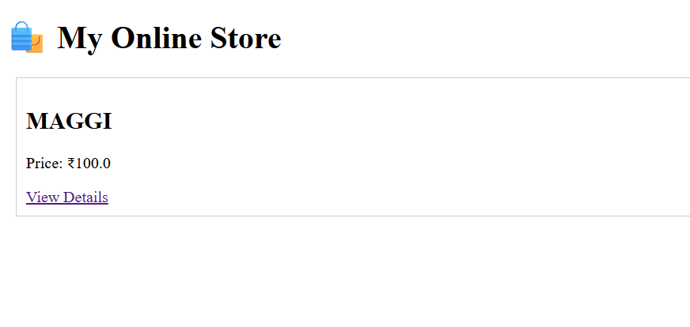




8. Application of the Project
The e-commerce website developed in this project can be applied in several real-world domains. It provides a foundation for building commercial platforms that facilitate online shopping and digital transactions. With the integration of Django, HTML, CSS, and databases, this system demonstrates how web technologies can transform traditional business models into digital solutions.
The major applications of this project are as follows:
- Online Retail Stores:
The system can be used by small and medium-sized businesses to create online stores where customers can browse products, view details, and make purchases. It eliminates the need for a physical shop and enables businesses to reach a global audience.
- Grocery and Food Ordering Systems:
The same framework can be extended to create grocery delivery websites or restaurant ordering systems, allowing users to select products or meals and place orders online.
- Educational and Institutional Sales:
Colleges or universities can use similar platforms to manage and sell materials such as books, stationery, and merchandise through an internal e-commerce system.
- Inventory and Stock Management:
The backend module of this project can be customized for businesses to monitor their stock levels, track sales, and manage inventory in real-time.
- Product Advertisement and Promotion:
Vendors can use the platform to display and promote their products, post discounts, and manage promotional campaigns, enhancing customer engagement.
- Customer Relationship Management (CRM):
The website can be integrated with CRM tools to maintain records of customer preferences, feedback, and order history, helping businesses provide better service and personalized recommendations.
- Mobile Commerce (m-Commerce):
By adapting this website to mobile-responsive designs or mobile applications, it can serve as a base for m-commerce platforms that allow shopping via smartphones and tablets.
- Digital Payment and Checkout Systems:
The project can be further extended to include secure online payment gateways, making it a complete digital shopping solution.
- Learning Platform for Web Development:
This project can also serve as an educational resource for students learning Django, database management, and web development principles, providing hands-on experience with real-world applications.
- Multi-Vendor Marketplace (Future Scope):
With modifications, the same structure can be scaled into a large platform supporting multiple sellers and customers, similar to popular e-commerce systems like Amazon or Flipkart.
9. Limitations of the Project
Although the developed e-commerce website demonstrates the core functionalities of an online shopping system, it still has certain limitations that can be addressed in future enhancements. These limitations mainly arise due to the project’s scope, time constraints, and the use of basic tools and frameworks for demonstration purposes.
The key limitations of this project are as follows:
- Limited Functionality:
The current version of the website focuses on fundamental operations such as product display, cart management, and order placement. Advanced features like product reviews, ratings, and wishlists are not yet implemented.
- Lack of Payment Gateway Integration:
The system does not currently support real-time online payments through credit or debit cards, UPI, or third-party payment gateways. Purchases are simulated without financial transactions.
- Basic User Interface:
The frontend design is simple and minimal, created primarily for functionality rather than aesthetic appeal. It can be further enhanced with responsive design, animations, and advanced CSS frameworks for a better user experience.
- Single-Vendor Limitation:
The existing system is designed for a single administrator or store owner. It does not yet support multi-vendor operations where multiple sellers can manage their own products independently.
- No Real-Time Notifications:
The project does not include email or SMS notifications for order confirmations, shipping updates, or user authentication alerts, which are common in modern e-commerce systems.
- Security Features Are Basic:
Although Django provides built-in authentication and session management, additional security layers such as CAPTCHA verification, two-factor authentication, and encrypted payment storage are not implemented.
- Limited Scalability:
The system is developed and tested on a local environment. It may require optimization and a cloud-based database to handle large-scale traffic and data when deployed publicly.
- No Mobile Application Integration:
The platform currently runs only on web browsers. There is no corresponding Android or iOS app version, which limits accessibility for users who prefer mobile shopping.
- No Automated Inventory Updates:
The inventory levels do not automatically adjust based on customer purchases. This could lead to stock management errors if multiple users place orders simultaneously.
- Absence of Advanced Analytics:
The project does not yet include data analysis tools for tracking customer behavior, sales trends, or performance metrics that are crucial for decision-making in business environments.
Despite these limitations, the project successfully demonstrates the core idea of a functioning e-commerce website and serves as a solid foundation for future development. Enhancements such as integrating payment systems, improving the user interface, and adding advanced features can transform it into a complete commercial platform
10. Bibliography
- Django Software Foundation. Django Documentation. Available at: https://docs.djangoproject.com
- W3Schools. HTML, CSS, JavaScript, and Django Tutorials. Available at: https://www.w3schools.com
- GeeksforGeeks. Django Framework and Python Web Development Tutorials. Available at: https://www.geeksforgeeks.org
- TutorialsPoint. Complete Guide to Django and Web Technologies. Available at: https://www.tutorialspoint.com/django
- MDN Web Docs. Web Development Resources and References. Available at: https://developer.mozilla.org
- Stack Overflow. Discussions and Solutions for Django Development. Available at: https://stackoverflow.com
- Python.org. Official Python Language Documentation. Available at: https://www.python.org/doc/
- Real Python. Practical Django and Web App Development Tutorials. Available at: https://realpython.com
- FreeCodeCamp. Responsive Web Design and Web Development Learning Platform. Available at: https://www.freecodecamp.org
- DigitalOcean Community. Deploying and Managing Django Applications. Available at: https://www.digitalocean.com/community/tutorials
- Coursera. Full Stack Web Development with Python and Django. Available at: https://www.coursera.org
- GitHub. Open Source Django Projects and Code Samples. Available at: https://github.com
- YouTube. Django Web Application Development Tutorials. Available at: https://www.youtube.com
- Medium. Articles on Django Best Practices and Web Frameworks. Available at: https://medium.com
- Amrita Vishwa Vidyapeetham Learning Resources. Computational Thinking and Web Project Guidelines (AID Department).

.
11. GITHUB LINK OF THE PROJECT

